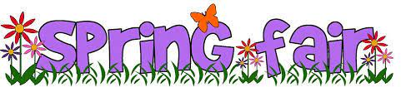
Saturday, May 27th
11:00 am to 2:00 pm
10 Lockview Road
Fall River, NS
This is a cash event
Face Painting, Cotton Candy, Snow Cones, Popcorn, Hot Dogs, Bouncy Castles, Cake Walk, Sucker Pull, Bingo, Mini Putt, & lots more FUN Fair Games!!
Ticket Prices:
5 tickets - $5.00
12 tickets - $10.00
25 tickets - $20.00
Class Basket Raffle – Be sure to buy tickets to win a beautiful class basket.
Tickets are 5 tickets for $5.00, 10 tickets for $10.00, or 25 tickets for $20.00

